Ever thought of finding the career of your dreams as a Criticalist at PetICU in Queensland, Australia?

Permanent and Locum basis available.

Description
Living and working through a pandemic is one thing but taking care of yourself during it is another. Take a break! Come and work with us, in Australia - the boarders have opened! Come be part of the Pet ICU team!
We are experiencing unprecedented and exciting growth as a business and are ready to expand our well-established team! The PetICU located in sunny Brisbane is looking for a Criticalist in Emergency Medicine and Critical Care who is wanting to join our progressive, innovative, cutting-edge, team on a permanent or locum basis.
You will be working alongside our ECC Fellow Ellie Leister who is an expert in mechanical ventilations and all creepy crawlies including ticks and snake envenomation. Your will also be working with residents in training, and specialists from all disciplines; Medicine, Surgery, Cardiology, Oncology, Ophthalmology, Dermatology, Dentistry and Physiotherapy along with advanced equipment, cutting edge technology and purpose built facilities. You will be able to enjoy both primary case management of critical patients and co-manage of cases with other specialties.
The Pet ICU practice is located in Underwood, Brisbane and has been designed as a state-of-the-art facility to ensure that the best diagnostics and treatment options are available for every patient. Pet ICU is very well-appointed with all the equipment needed to monitor and treat critical patients. Pet ICU is a place of continuous learning with opportunity to engage in prospective research as well as mentoring of residents, interns, and vet students. The kindness and dedication of our team shines through in the care and treatment we provide within our 'patient first' culture. The Pet ICU provides around the clock patient care 365 days a year.

CLICK HERE FOR A SHORT VIDEO ABOUT THE ROLE

About the Location

Planning on moving to the capital of the Sunshine State? Brisbane is a great destination for families, professionals and students! If a working holiday is what you’d prefer, Brisbane is the place to be!
Queensland's capital is famous for the river life and wide expanse of greenery, it's ports and beaches and unique, relaxed lifestyle. From hiking through rainforests to sitting on our amazing beaches and soaking up the sun. For those that are more adventurous or like to party, you are in the midst of it all.
You are treated to historical pub venues, world class sporting grounds, amusement parks, and night clubs that extend to every corner. The river presents a diverse range of ecosystems moving from up in the mountains, winding through the valley out to the Pacific Ocean. Bushland reserves are in almost every suburb, there literally is a National Park anywhere you are.

About Our Team

We are a diverse and harmonious team who always support each other. Our values focus on gold-standard patient care and delivering the best outcome possible. We have a mix of mums raising families to nurses buying their first home. Our team consists of people with a wide variety of hobbies and sports including martial arts, kick boxing, taekwondo, road running, propagating plants, bee keeping, hiking, camping and racing sailing. You will find support here! You will find family here! You will find friends here and if you like you can bring your friends too!

CLICK HERE FOR A TOUR OF PET ICU AND TO MEET SOME OF THE TEAM
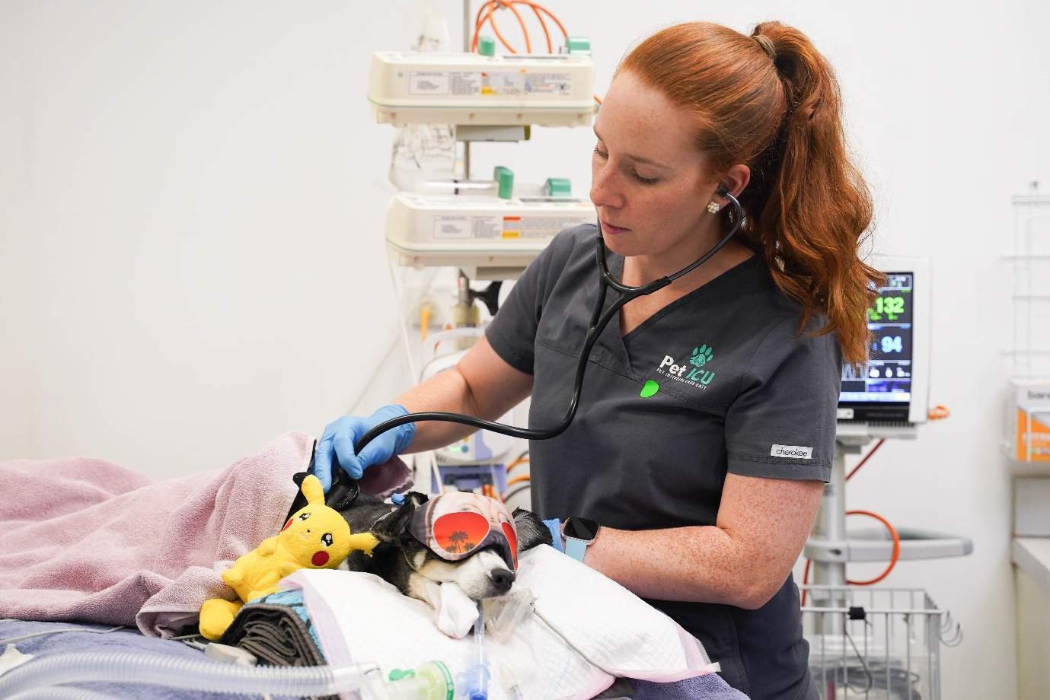

"We challenge the heart, support the mind, thrive on trust and operate with integrity, compassion and kindness in everything we do."

Requirements
About You
- A Fellowship or Diplomate qualified Criticalist with a passion for intensive care veterinary medicine.
- A kind and compassionate communicator with ability to make decisions in collaboration with all people involved in the case management (especially the owner).
- An innovative, forward-thinking individual who embraces growth and values teamwork.
- Ability to manage a high caseload using best-practice principals.
- Experience in clinical teaching all aspects of emergency and critical care medicine, from final year students through to interns or residents in training.
Benefits and Cool Stuff
- An appealing base salary that will reflect your abilities and future performance + Superannuation (10% loading towards your pension fund) + Competitive bonus structure
- Sponsorship and relocation support available
- The opportunity to create your dream role! We have a variety of different areas for you to choose to spread your time across: from clinical shifts on the floor, mentoring residents in a structured training program, teaching at Animal Emergency Australia, clinical research, and teaching at James Cook University
- No overnight shifts
- 5 weeks' annual leave
- 1 year maternity/paternity leave
- 1 week professional development leave a year
- Employee pet wellness discounts
- Uber eats on the house for recharging your batteries on shift
- Fatigue management program
- Work+life harmony
- Workplace social events
- A fun, collaborate and fully supportive team that works close to the best beaches in the world!

Any interest in the role will be strictly confidential. For more insight into PetICU and to apply for this role, please contact Dr Ellie Leister via email: eleister@peticu.com.au and CC tamin@peticu.com.au. Alternatively, please contact Ellie on (+61) 439606810.

Don’t forget to refer your friends!

