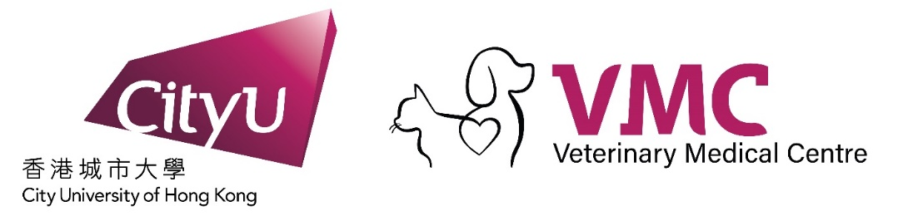

Small Animal Veterinary ECC Specialist & ER Vet
(4 days on 4 days off shift pattern)

About US
CityU Veterinary Medical Centre (CVMC), owned by City University Hong Kong, serves an extensive small animal clientele from across Hong Kong. We are the largest Small Animal clinic in Hong Kong with over 35,000 sq ft which includes 22 consultation rooms, 7 surgical theatre suites with a dedicated induction and recovery area, full on-site STAT diagnostic laboratory, pharmacy and dedicated client areas for emergency and regular appointments. Our medical imaging and diagnostic capabilities include a 1.5 Tesla MRI, 64 slice CT, digital radiography, ultrasound, color doppler echocardiography, intra-operative fluoroscopy and endoscopy.

Services and specialties include: 24/7 Emergency & Critical Care, Internal Medicine, Neurology, Dermatology, Cardiology, Surgery, Oncology, Anesthesiology, Diagnostic Imaging, Dental and Primary Care.

We offer clinicians an opportunity to work in a state-of-the-art facility, side-by-side with a large group of specialists in Oncology, Dermatology, Surgery, Cardiology, Emergency & Critical Care, Internal Medicine, Neurology, Anesthesiology, Diagnostic Imaging as well as a team of dedicated Primary Care and Emergency clinicians, nurses and friendly support staff.

Requirements for ECC Specialist & ER Vet
- If you are a residency-trained veterinarian or board-certified specialist looking for a highly trained and organized team and a busy, complex case load, we want to meet you!
- If you have completed an approved training program but are yet to finalized exams are also strongly encouraged to apply

Requirements for ER Vet
- Bachelor of Veterinary Medicine with minimum 2 years of Small Animal Emergency Medicine

Benefit Packages We Offer:
- Competitive Salary
- Generous Continuing Education (CE)
- Extended Worldwide Health Medical Benefits package for our employees, their spouse, and children (Medical, Dental, & Vision paid by clinic)
- Relocation Allowance
- Housing Allowance
- Paid Vet Licensing Dues
- Paid Annual Leave
- Paid Study Leave
- Generous Veterinary Discounts
- Comprehensive Immigration Assistance provided
- No On Call Duty

Others Benefits of Working in Hong Kong:
- Low income tax rate of ~17%
- Great schools, superb restaurants, and plenty of recreational opportunities
- Over 400 miles of hiking trails and over 40 beaches
- Hong Kong is one of the safest large cities in the world
- Incredibly easy to get around with its robust mass transit system that is clean and efficient
You can learn more about us and our team at https://cityuvmc.com.hk/en/home/
If you are interested in the position or wants to know more, please write to job@cityuvmc.com.hk or karenlo@cityuvmc.com.hk (Talent Acquisition Manager)
*All conversations and CV will be treated confidentially.

